Datchworth Scarecrows
Vote for your favourite Children’s Book Character
24th May to 31st May 2020
In celebration of the 200th Anniversary of our Village School
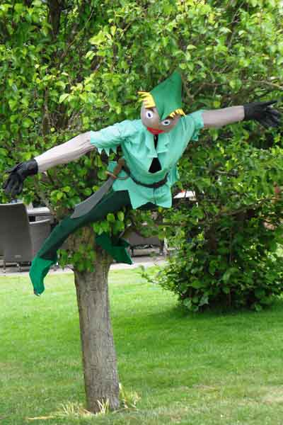

- 15 Scarecrows; 7 Children/Carer Entries & 8 Adult Entries; all identified by a letter of the alphabet; a prize for the winner in each category. Children/Carer Entries will be starred*

- Located in Datchworth Green(A), Wheatcotes (B), Hollybush Lane (C -opposite school); along Brookbridge Lane (D, E, F, G & H); Nutcroft (J); Great Lawne (K, L, Q ); along Bramfield Rd (M, N & P – Stables opposite The Horns pub)

- Your voting will be combined with that of our “expert” judge, Lynn Horsley, in the Strictly style

- Email your top voting preference in each category to lynda.dent@zen.co.uk by 1st June

Enjoy the exercise and respect social distancing

